



I am going to play Challenger Baseball today

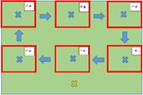 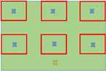

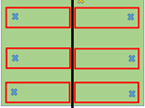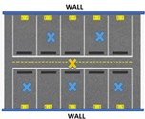

CB is going to look a little bit different this season

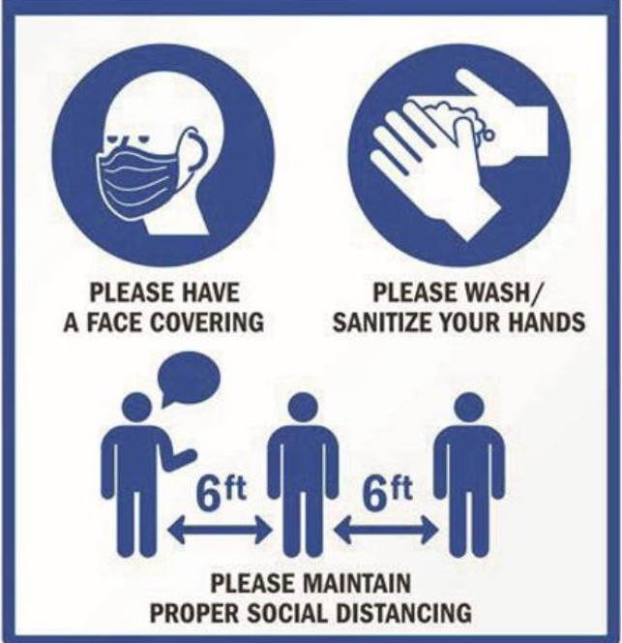

For everyone to stay safe, I will have to follow some safety rules



I will always wear my mask





I will sanitize or wash my hands before entering the diamond

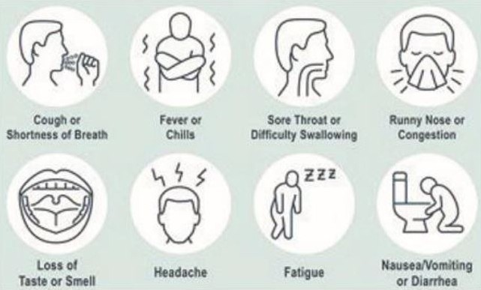

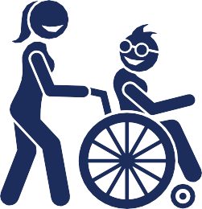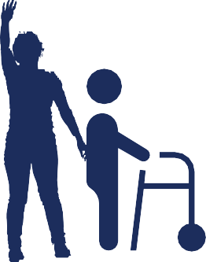

My coaches will ask me a few questions about my health before I can play

 

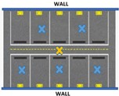

I will go directly into my designated space

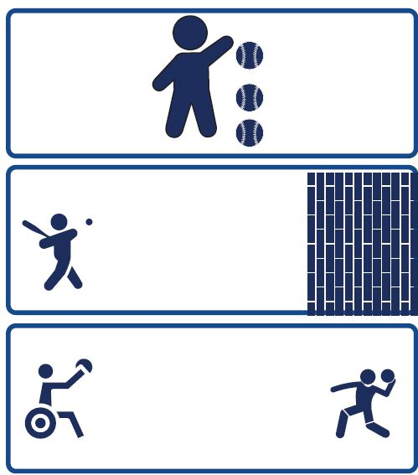

I will get to play different games while I am in my space

|  |  |  |  |  |  |  |  |  |  |
| --- | --- | --- | --- | --- | --- | --- | --- | --- | --- |
|  | |  | |  | |  | |  | |
|  |  | |  | |  | |  | |  |
|  | |  | |  | |  | |  | |
|  |  | |  | |  | |  | |  |
|  | |  | |  | |  | |  | |
|  |  | |  | |  | |  | |  |
|  | |  | |  | |  | |  | |
|  |  | |  | |  | |  | |  |
|  | |  | |  | |  | |  | |
|  |  | |  | |  | |  | |  |
|  | |  | |  | |  | |  | |
|  |  | |  | |  | |  | |  |

|  |  |  |  |  |  |  |  |  |  |
| --- | --- | --- | --- | --- | --- | --- | --- | --- | --- |
|  | |  | |  | |  | |  | |
|  |  | |  | |  | |  | |  |
|  | |  | |  | |  | |  | |
|  |  | |  | |  | |  | |  |
|  | |  | |  | |  | |  | |
|  |  | |  | |  | |  | |  |
|  | |  | |  | |  | |  | |
|  |  | |  | |  | |  | |  |
|  | |  | |  | |  | |  | |
|  |  | |  | |  | |  | |  |
|  | |  | |  | |  | |  | |
|  |  | |  | |  | |  | |  |

I will wave and talk to my friends from my designated space



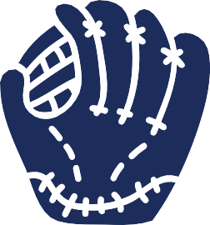







I will clean my equipment when I am done playing





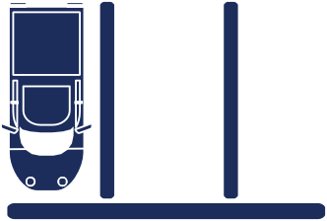

I will leave my space after my coach has

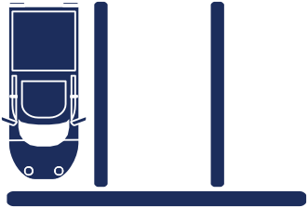

Team 1, you can leave

given me permission to do so



Bye Coach!

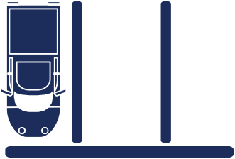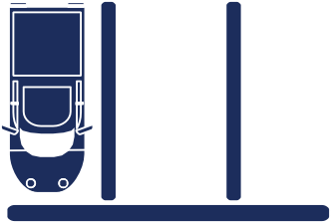



I will say goodbye to my friends and

coaches at the end of the session

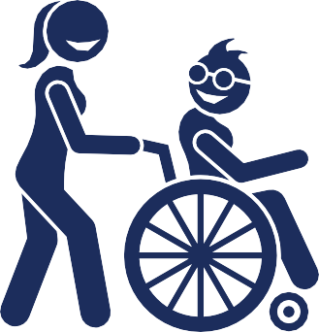



I will have lots of fun