**Support Opportunities from Jays Care for Challenger Baseball Families Amidst COVID-19**



We’ve heard from hundreds of Challenger Baseball families across Canada about their successes, their struggles and their ideas on how Jays Care Foundation can help during this difficult time. In response to the feedback we have received, we have identified five distinct areas in which Jays Care can help Challenger Baseball families:

1. **Jays Care Unstoppable Kids Challenges** (available in French and English, with new challenges posted every Monday: <https://www.mlb.com/bluejays/community/jays-care/unstoppable-kids/challenges>).

*To access the application for following opportunities, please contact your Challenger Baseball League Coordinator, School Coach, or Program Leader:*

1. **$100 Grocery Gift Cards provided by Sobeys** (can be used at Sobeys and Freshco stores across Canada);
2. **$25 Indigo Gift Cards provided by the Indigo Love of Reading Foundation** (can be redeemed online for books for children and youth);
3. An **Adaptive Equipment Kit from Flaghouse Inc.** (families can choose from five different kit options); and/or,
4. Access to the **Video Pen Pal Project** (this opportunity matches Challenger Baseball athletes with a video pen pal from across Canada).

These initiatives, created in collaboration with Challenger Baseball families across Canada and our partners, has been designed to help in the following ways:

1. Help kids, athletes and families continue to nurture each person’s unstoppable nature while staying fit and having fun;
2. Increase access to groceries and proper nutrition for families who may be struggling;
3. Increase access to literacy opportunities and reading materials for athletes who while at home may otherwise not have access;
4. Increase access to specific adaptive equipment and resources for play, learning, and/or recreation therapy to self-run *Challenger Baseball* at home while there is little to no access to community programming; and,
5. Increase access to opportunities specifically designed to reduce feelings of isolation and loneliness amongst our athletes and their families.

Jays Care is very proud to support Challenger Baseball athletes across Canada and we want everyone to know that we will do as much as we can to help families that are struggling during this public health emergency. As always, please don’t hesitate to contact the Manager, Inclusive Programs and Outreach with any questions or comments at [Alysha.Kavanagh@bluejays.com](mailto:Alysha.Kavanagh@bluejays.com)

[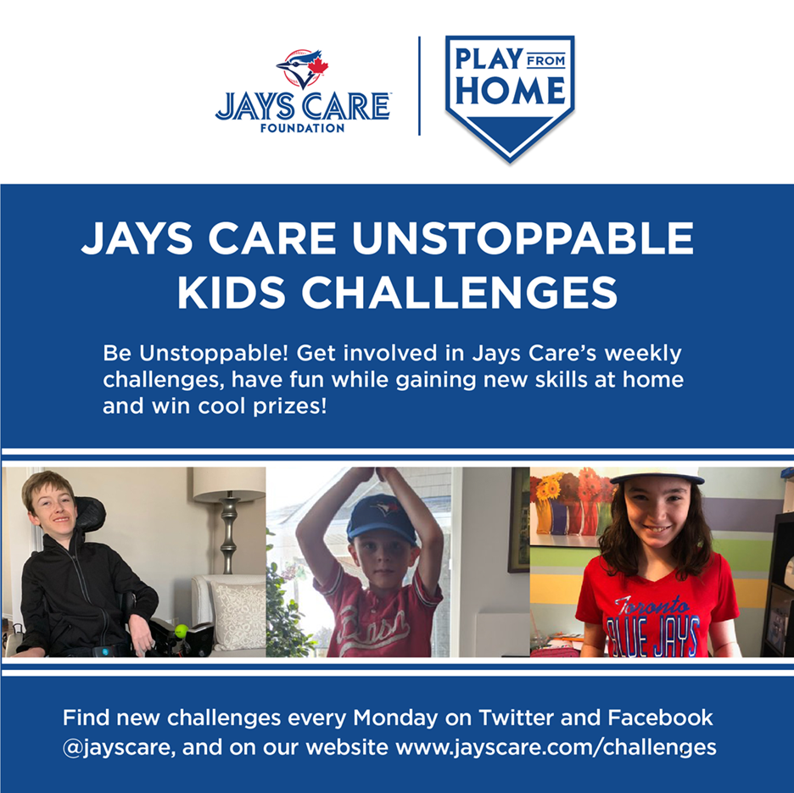](https://www.mlb.com/bluejays/community/jays-care/unstoppable-kids/challenges)