CHALLENGER BASEBALL COMMUNICATION RESOURCE
VISUAL TOOLS, STRATEGIES AND TEMPLATES

Toronto Blue Jays, Jays Care Foundation and all related marks and designs are trademarks and/or copyright of Rogers Blue Jays Baseball Partnership. © 2018

TABLE OF CONTENTS

INTRODUCTION
Purpose of this Resource 4
What is a Visual Tool? 4
Why are Visual Tools Useful? 4
Effective Delivery of Visual Tools 5
What Visual Tools are Included in this Resource? 6
VISUAL TOOLS
Picture Exchange Communication System (PECS) 6
First/Then Board 7
Wave/Visual Schedule 8
Visual Timer 9
Handheld Visual Aid 10
“I’m Working Towards” Token Board 11
Baseball Field Visual 12
Zones of Regulation 13
Whiteboard 14
PRINTABLE TEMPLATES
Picture Exchange Communication System (PECS) 16
First/Then Board 20
Wave/Visual Schedule 21
Visual Timer/ 22
“I’m Working Towards” Token Board 23
Baseball Field Visual 24
Zones of Regulation 25
APPENDIX
Additional Tips and Strategies 26

PURPOSE OF THIS RESOURCE
The purpose of this resource is to provide coaches, parents, educators and buddies with visual tools for communication and motivation that can help contribute to each athlete’s success in Challenger Baseball.

This resource includes:
- A description of the visual tools
- Strategies for how to use the tools to communicate effectively with your athlete(s)

If you would like to create additional resources to use with your team, this resource also includes:
- Instructions about how to create each individual visual tool, and
- Printable templates of each visual support.

* Not all individuals with cognitive, communicative and physical needs require visual supports. Please ensure that these tools will be useful for the athlete by asking them directly or speaking with their parent(s), guardian(s) or support worker.

WHAT IS A VISUAL TOOL?
A visual tool is a type of approach that uses pictures to assist with communication, motivation and engagement in an activity for individuals with cognitive, communicative and physical needs.

WHY ARE VISUAL TOOLS USEFUL?
Visual tools can help individuals understand the expectations and the timing of an activity. These supports are handheld and in some cases, the individual is able to manipulate the resource on their own with support and direction from their buddy (i.e., choosing a VelcroTM piece to move from one place to another). In other cases, the buddy can manipulate the resource for the athlete. Because Visual Tools can help the individual understand what is expected of them in the near future or the steps they need to take to reach short-term goals, they are excellent tools to help monitor and evaluate the success of your Challenger Baseball program!
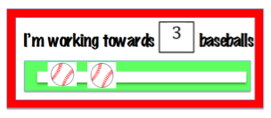
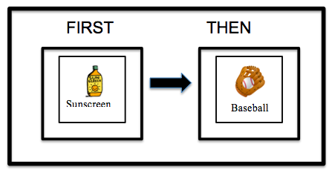

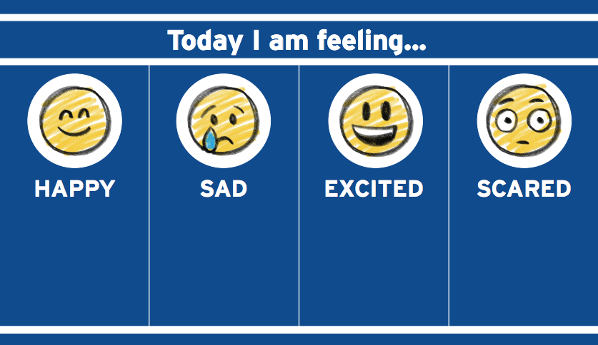

EFFECTIVE DELIVERY OF VISUAL TOOLS
Visual aids can be effective tools to use with individuals with various needs if used well! It is crucial that they are delivered efficiently to the athlete in order to promote successful communication between the two parties.

Below are 5 strategies to help effectively communicate with the athlete using visual tools:

- Use a clear and concise voice / simple instructions
  - Use clear and simple directions by giving one instruction at a time. Ensure that you are never talking down to the athlete.

- Reach the athlete’s level
  - Squat, bend, take a knee…do whatever you can to reach the athlete’s level so that they can hear you and see the visual tool.

- Determine needs before asking for eye contact
  - There are some individuals with cognitive or communicative needs who are unable to look at others directly in the eyes, however just because they are not looking, does not mean they are not listening. Make sure that the athlete is given time to process the information before continuing to the next instruction.

- Promote independence
  - Encourage the athlete to manipulate the visual tools with directions from the buddy by having the athlete pull and place instructions on and off of the tool will not only help the individual with fine motor skills but also with self-regulation skills.

- Consistency is key
  - If the buddy starts the day using visual tools, they should continue to use the supports throughout the session in order to ensure consistency.

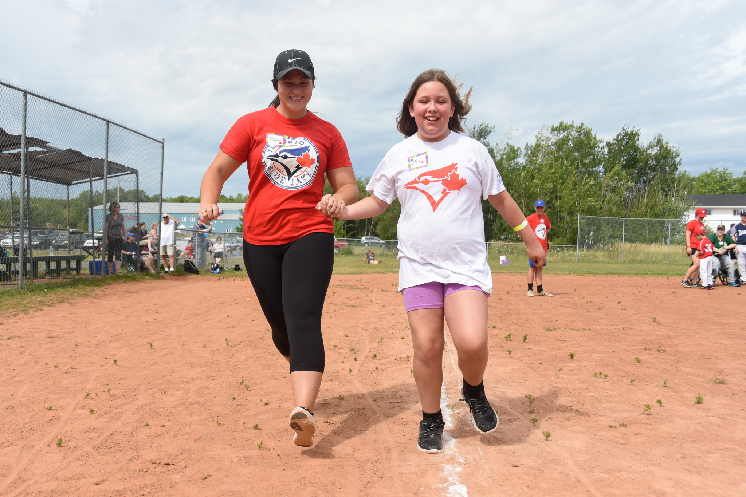

WHAT VISUAL TOOLS ARE INCLUDED IN THIS RESOURCE?
The following resources are included in this package:

- Picture Exchange Communication System (PECS)
- First/Then Board
- Wave/Visual Schedule
- Visual Timer
- Handheld Visual Aid
- “I’m Working Towards” Token Board
- Baseball Field Visualization
- Zones of Regulation
- Whiteboard Tool

In this manual you can find a detailed description of the tool, ideas for how to use with your athlete(s), and instructions on how to make additional recourses.

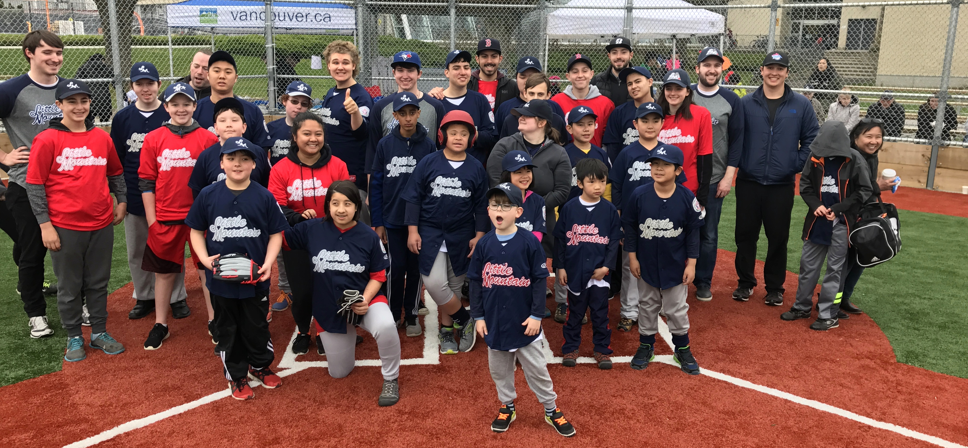

1. Picture Exchange Communication System (PECS)
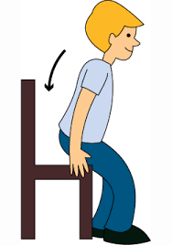

Break Please

Baseball

Picture Exchange Communication System (PECS) are a way for individuals with limited communication skills to communicate through pictures.

HOW TO USE:
PECS can be used with First/Then boards, visual schedules, and motivational boards. PECS are an effective way to promote independence as it not only provides the individual with a voice, but it also allows the athlete to manipulate the tools on their own.
The athlete can use the PECS to communicate needs/wants with their buddy. For example, if the athlete needs a break, then they can move the break PEC onto a visual tool to show their buddy how they are feeling.

The buddy can also manipulate the PECS to display directions and further instructions to the athlete. For example, they can use the First base and Second base PECS to show the athlete how to run around the bases.

HOW TO MAKE (IF YOU CHOOSE TO MAKE YOUR OWN ADDITIONAL RESOURCES):
- Go to page 6
- Create multiple square shapes on a word document
- Find a visual to match the instruction then place the visual inside of the square
- Create a text box and place the instruction underneath the visual
- Print
- Laminate (optional)
- Cut out visuals
- Place VelcroTM on the backside of the visual
- The PECS are ready to use!

2. FIRST / THEN BOARD
THEN
FIRST

Sunscreen
Baseball

The First/Then board is used to motivate an individual to actively engage in an activity. Buddies can use the First/Then board to encourage the athlete to participate in warm-up activities, skills and drills, game play and more. The First/Then board can also be used as an organizational tool/schedule to help the athlete recognize what they can expect to come next.

HOW TO USE:
The First/Then board uses preferred activities as a motivational tool to accomplish a task. The board provides step-by-step instructions that use reinforcement as a way to encourage the athlete.

Under the FIRST column, place a PEC that describes an activity or an instruction that expects to be completed by the athlete. Under the THEN column, place a preferred activity that will motivate the athlete to accomplish the first task. For example, “First... sunscreen, Then… baseball!”

The First/Then board can also be used as a schedule or as a way to assist with simple instructions. For example “First … Warm Up, Then … Game Play” or “First …Hit, Then…Run.”

HOW TO MAKE (IF YOU CHOOSE TO MAKE YOUR OWN ADDITIONAL RESOURCES):
- Go to page 20
- Print out the First/Then board template
- Laminate (optional)
- Cut out the board
- Place VelcroTM in the First/Then boxes. Ensure that the VelcroTM texture is opposite to the VelcroTM on the PECS

3. WAVE/VISUAL SCHEDULE
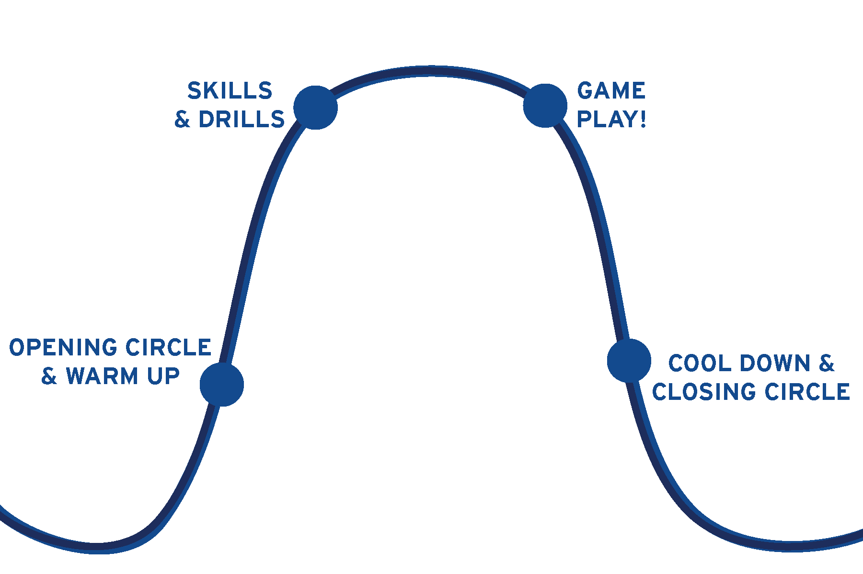

The Wave is a visual strategy to structure a Challenger Baseball session for individuals who require clear expectations and routines in their day.

HOW TO USE:
The Wave can be used as a visual schedule to show the athlete how to work through a session. The buddy can either place a baseball player PEC (below) on each of the dots (opening circle & warm up, skills and drills, game play, and cool down & closing circle) or place specific Wave PECS (below) outlining the activities that they will be completing at each stage. The Wave activity PECS can be found on page 18 in this resource.

This visual tool can be used as an independent resource or as a group schedule. This tool can be found on the handheld visual resource, however it can also be printed, in an enlarged format (page 23) and hung up if it is being used as a group schedule. This schedule can be referred back to throughout the session.

HOW TO MAKE (IF YOU CHO)SE TO MAKE YOUR OWN ADDITIONAL RESOURCES):
- Go to page 21
- Print out the Wave template (enlarge if it is being used as a group schedule)
- Print out a baseball player PEC or a Wave PEC
- Laminate (optional)
- Cut out the Wave visual
- Cut out baseball player or Wave PEC
- Place VelcroTM on each dot of the Wave
- Place the opposite texture of VelcroTM on the PEC of choice (baseball player or Wave PECS)

4. VISUAL TIMER

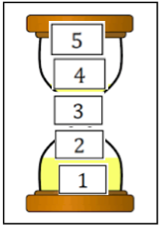

The Visual Timer is a tool that helps promote organization and self-regulation skills. Buddies can use this tool in several ways throughout a Challenger session to help the athlete actively engage in the game/activities.

HOW TO USE:
Buddies can use the Visual Timer as a resource to assist with turn taking and transitions as well as a strategy to help the athlete track the skills/drills they are completing. The timer has five pieces/dots of VelcroTM placed vertically down the middle of the timer image, which corresponds with the numbers 1-5. Once an athlete has accomplished a skill, waited their turn, or completed one minute, the buddy can then request the athlete to remove a number from the timer and hand it to the buddy. Once all five numbers have been detached, then the task has been achieved.

Before using the timer, the buddy should clearly explain what the next steps would be once all five numbers have been removed. The buddy can also decide the amount of numbers that are used each time.

Turn Taking: “Okay Johnny, there are now 3 people ahead of us to bat… can you please remove the #4?”

Transitions: “There are 5 more minutes before we start practicing our throwing skills… there are now 4 more minutes.”

Skills/Drills counter: “You need to throw the ball 5 times before we move to the next activity.” (After each throw the athlete or buddy can remove numbers)

HOW TO MAKE (IF YOU CHO)SE TO MAKE YOUR OWN ADDITIONAL RESOURCES):
- Go to page 22
- Print out the visual timer template
- Laminate (optional)
- Cut out the Visual Timer tool
- Cut out each number (1-5) individually
- Place five pieces/dots or a strip of VelcroTM vertically down the
middle of the timer
- Place the opposite texture of VelcroTM on the back of each number
- Stick the numbers onto the timer to prepare for use

* For those who requested pre-made handheld visual aids, the Visual Timer is included in the bundle as a separate tool.

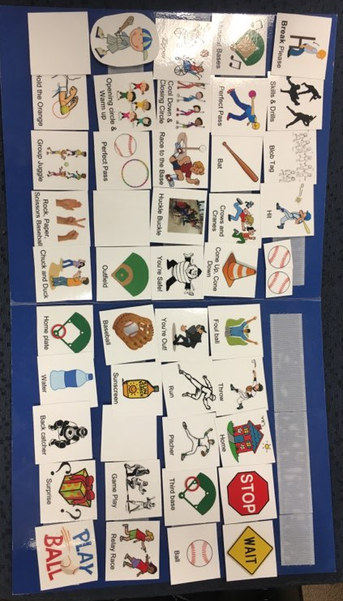
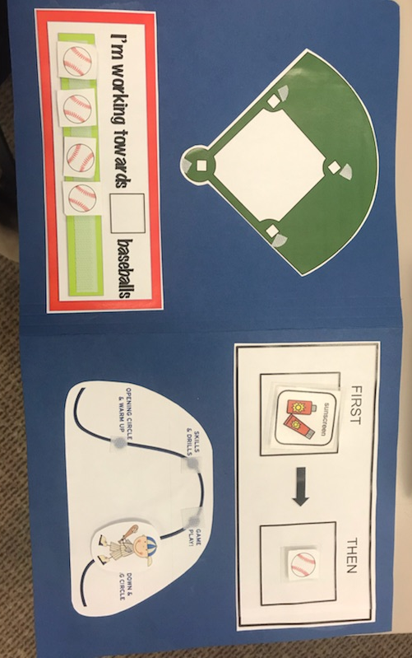
5.HANDHELD VISUAL AID

The Handheld Visual Aid is a portable resource made up of the First/Then board, Wave/Visual Schedule, Baseball Field Visual, ‘I’m Working Towards’ token board and PECS on one surface. This aid allows the buddy to carry multiple visual tools and PECS at the same time.

HOW TO USE:
The Handheld Visual Aid is designed to carry multiple visual tools at one time. The front page is made up of the First/Then board and the Wave/Visual Schedule and the back consists of the Baseball Field Visual as well as the ‘I’m Working Towards’ token board. On the two inside pages of the resource, there is VelcroTM to hold all of the PECS that will be used throughout a Challenger session. If the buddy is unable to fit all of the PECS inside of the resource, then it may be helpful to keep the PECS in a separate location and fill the resource with the PECS that will be in used the most during that session.

For reference on how to use each visual, visit the page numbers below

First/Then board……………………………Pg. 7
Wave/Visual Schedule……………………Pg. 8
“I’m Working Towards” token board…..Pg. 11
Baseball Field Visual……………………...Pg. 12

HOW TO MAKE (IF YOU CHOOSE TO MAKE YOUR OWN ADDITIONAL RESOURCES):
Materials:

- File folder
- Scissors
- Glue

- VelcroTM
- Laminator (optional)
- Cut down the file folder to preferred size (pre-made resource size: 9.5x16.5)
- Print out:
  - First/Then board template
  - Wave/Visual Schedule template
  - Baseball Field Visual template
  - ‘I’m Working Towards…’ token board template
- Cut out visual tools
- Glue visual tools onto the front and back of the folder (Pre-made resource: front- First/Then, Wave/Visual Schedule. Back- Baseball Field Visual, ‘I’m Working Towards’ token board)
- Laminate (optional)
- Put VelcroTM in the First/Then boxes, on each point of the Wave, on the bases/positions on the Baseball Field Visual, and on the green rectangle on the ‘I’m Working Towards’ token board.
- Put the opposite side of VelcroTM on the PECS that will be used
- Place five rows of VelcroTM horizontally inside of the folder on each side
- Use the inside VelcroTM to hold extra PECS

6. “I’M WORKING TOWADS” TOKEN BOARD

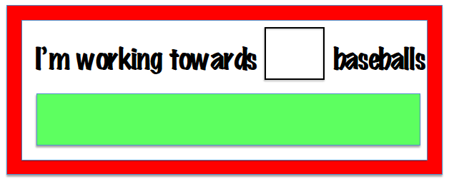

The ‘I’m Working Towards’ token board is a reinforcing tool used to help motivate athletes to reach personal goals and to stay engaged in activities.

HOW TO USE:
The buddy can use the token board as a way to encourage the athlete to participate in Challenger Baseball events and activities. It is important to establish a target/goal at the beginning of each session that the athlete is striving to achieve, such as breaks or special incentives, in order to ensure that the athlete is aware of what they are working towards throughout the day. The buddy can decide on the number of baseball PECS that the athlete will have to achieve before receiving their preferred activity by writing the chosen number in the box provided on the board (i.e. “I’m working towards 3 baseballs”). They will then explain to the athlete how many baseballs they will need to reach their goal.

It is crucial that the buddy clearly explains the steps/tasks that the athlete needs to complete in order to receive a baseball. For example, “Okay Nolan, if you throw the ball three times, then you will receive one baseball!”

The buddy can promote independence by handing the baseball PEC to the athlete to place on the board themselves. Throughout the session, the two participants can continue to count the number of baseballs that the athlete has and how many more they need to reach their goal, as a way to further motivate the individual.

HOW TO MAKE (IF YOU CHOOSE TO MAKE YOUR OWN ADDITIONAL RESOURCES):
- Go to page 23
- Print out the ‘I’m Working Towards…” token board template and baseball PECS
- Laminate (optional)
- Cut out ‘I’m Working Towards’ token board
- Cut out individual baseballs
- Place a long piece of VelcroTM horizontally within the green rectangle
- Place the opposite texture of VelcroTM on the back of the baseball PECS
- Use a dry-erase marker to write the number of baseballs they need to achieve in the square
- Stick the baseballs onto the board

7. BASEBALL FIELD VISUAL

The Baseball Field Visual is a great way to display step-by-step instructions about how to play baseball. This tool can be easily adapted to meet many needs as coaches and buddies can decide how they choose to manipulate the diamond as a way to further develop specific baseball skills.

HOW TO USE:
The Baseball Field Visual can be used in many ways to promote and enhance baseball skills. The Baseball Field Visual can assist with the understanding of base running, positions, and skills/drills. Each base on the visual has VelcroTM in order to move the baseball player PEC around the diamond. The buddy can explain that this PEC represents the athlete and then use the PEC to show the athlete where to run or play throughout the session.

This tool can also be enlarged and hung up on the dug out for group use.

The coach can use the Baseball Field Visual as a way to show athletes as a team what skills/drills they will be working on that day or what position they will be playing. VelcroTM can be placed on each base and position (i.e. shortstop, left field, back catcher etc.). Name cards of the athletes can be created to move around the tool in order to visually show the athletes the location of the position and where they are playing.

HOW TO MAKE (IF YOU CHOOSE TO MAKE YOUR OWN ADDITIONAL RESOURCES):
- Go to page 24
- Enlarge (optional)
- Print out the Baseball Field Visual
- Print out the baseball player PEC
- Cut out the Baseball Field Visual
- Cut out the baseball player PEC
- Laminate (optional)
- Place VelcroTM at each base / position
- Place the opposite side of VelcroTM on the back of the baseball player PEC and name cards (optional)

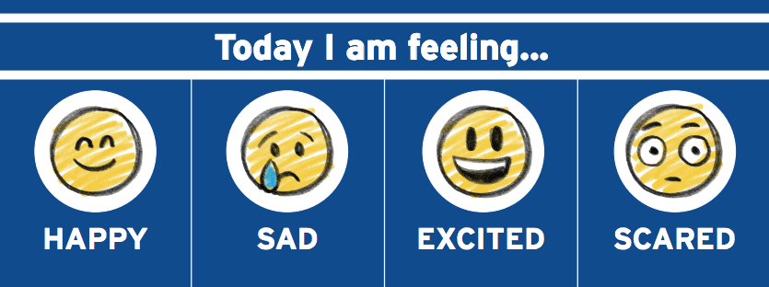
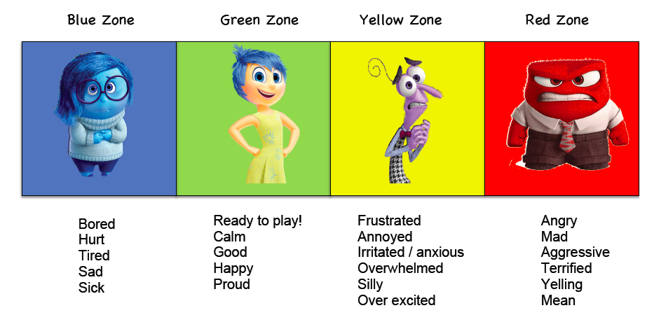
8. ZONES OF REGULATION

The Zones of Regulation tool is used to visually identify emotions. It assists the athletes with developing skills to help classify and regulate their feelings while also allowing buddies to recognize how athletes are feeling before a session begins.

HOW TO USE:
*This tool can be used both individually and as a group.

The Zones of Regulation tool uses colours (blue, green, yellow, red) and/or faces to represent different emotions. It is important to recognize how athletes are feeling before a session begins in order to understand the varying degrees of participation that correspond with each colour. For example, if an individual is in the green zone, then they are ready to participate and test limits, however if an individual is in the yellow zone, then the session will be all about having fun and attempting to move the athlete back to the green zone.

Blue: An individual who is feeling down (bored, hurt, tired, sad, sick)

Green: An individual who is feeling happy/content (ready to play, calm, good, proud)

Yellow: An individual who is feeling irritated (frustrated, annoyed, anxious, overwhelmed, silly, overexcited)

Red: An individual who is feeling angry (mad, aggressive, terrified, yelling, mean)

The visual can be used as an individual tool by having the athlete point to the colour that they are feeling before the session begins. As a group, the Zones of Regulation visual can be enlarged and hung up on the dugout. Names can be written on clothespins that the athletes can use at the beginning of the session to show what colour they are in by pinning their name onto the board.

HOW TO MAKE (IF YOU CHOOSE TO MAKE YOUR OWN ADDITIONAL RESOURCES):
- Go to page 25
- Print out the Zones of Regulation board
- Enlarge (optional)
- Cut out the Zones of Regulation board
- Laminate (optional)
- Write names on individual clothespins (optional)

9. WHITEBOARD TOOL
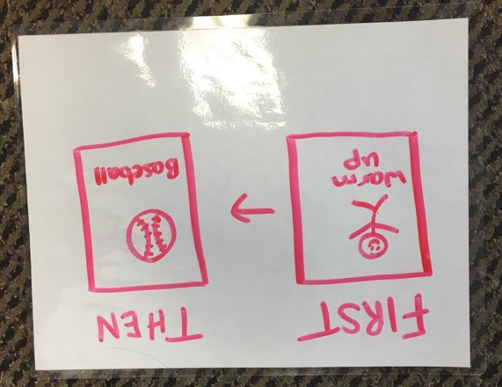

The Whiteboard tool is a surface that can be developed into several visual tools in order to help athletes work through a Challenger session. The Coach can manipulate the Whiteboard tool with the whole team while buddies can use the tool to communicate one-on-one with the athlete.

HOW TO USE:
*Requires a dry-erase marker for use

As a team, the Coach can adapt the Whiteboard tool to help visually display multiple elements of a Challenger Baseball session. The Coach can use the tool as a way to explain the skills/drills that the athletes will be working on that day, the batting lineup and/or the positions that the athletes will be playing.

The buddy can use the Whiteboard to create any visual tool (listed above) on the go. For example, the buddy can draw a First/Then board on the Whiteboard by creating two squares, writing First and Then on top of each box and drawing pictures of the instructions and preferred activities inside each of the squares. The Whiteboard can then be erased immediately and turned into a different visual tool.

HOW TO MAKE (IF YOU CHOOSE TO MAKE YOUR OWN ADDITIONAL RESOURCES):
- Get a blank piece of paper
- Laminate
- Use a dry erase marker to create into a visual tool

PRINTABLE TEMPLATES

Water
Home
Baseball

Surprise

Break Please

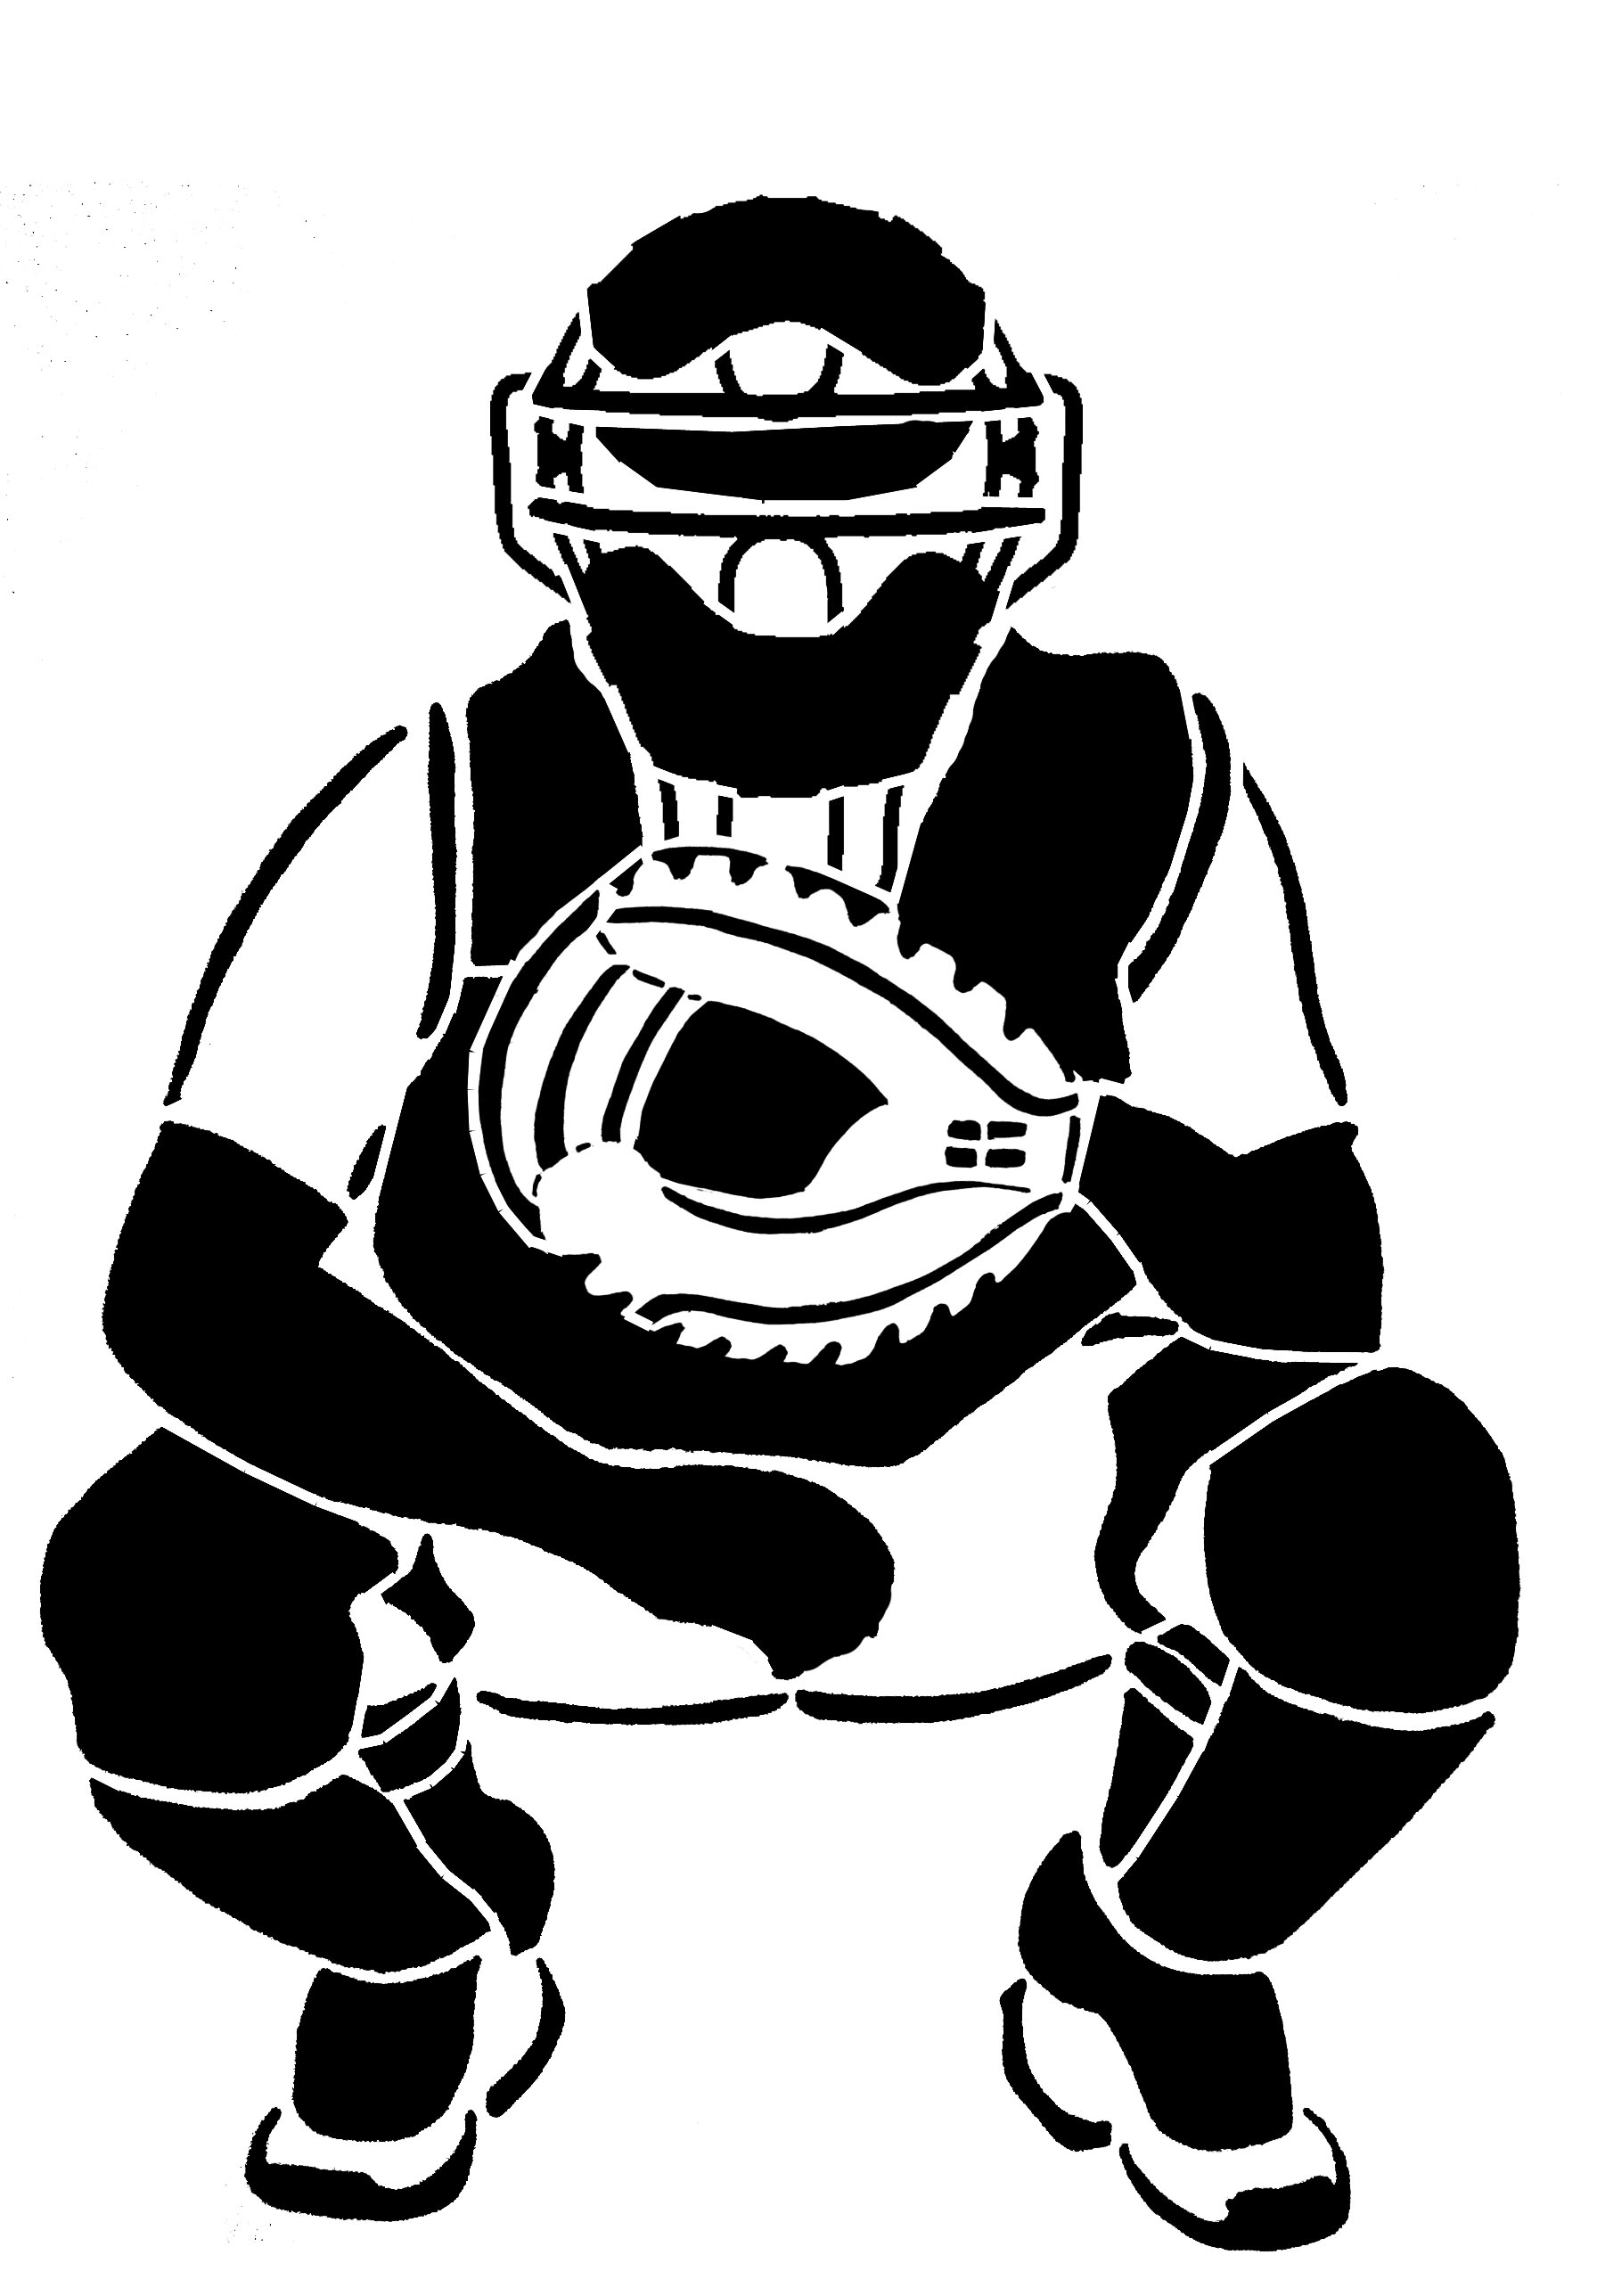

You’re Safe!
Back catcher
You’re Out!

Bat

Ball
Sunscreen

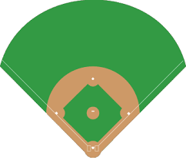
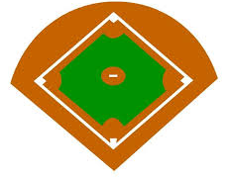

Outfield
Infield
Pitcher

Foul ball
Second base
First base

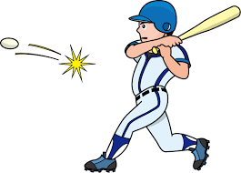

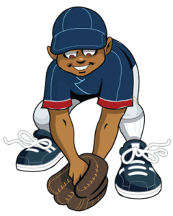
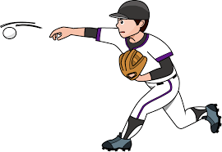
Fielding
Run
Throw

Hit
Home plate
Third base

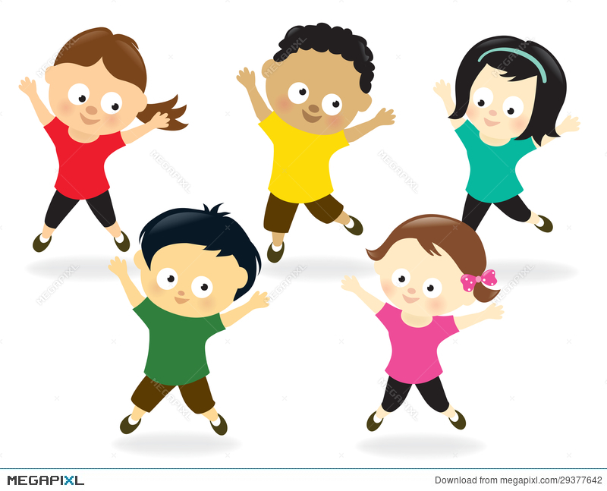
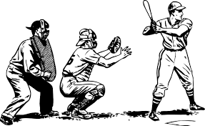
Perfect Pass
Huckle Buckle
Crows and Cranes
Blob Tag
Cone Up, Cone Down

Opening circle & Warm up
Skills & Drills
Game Play

Cool Down & Closing Circle

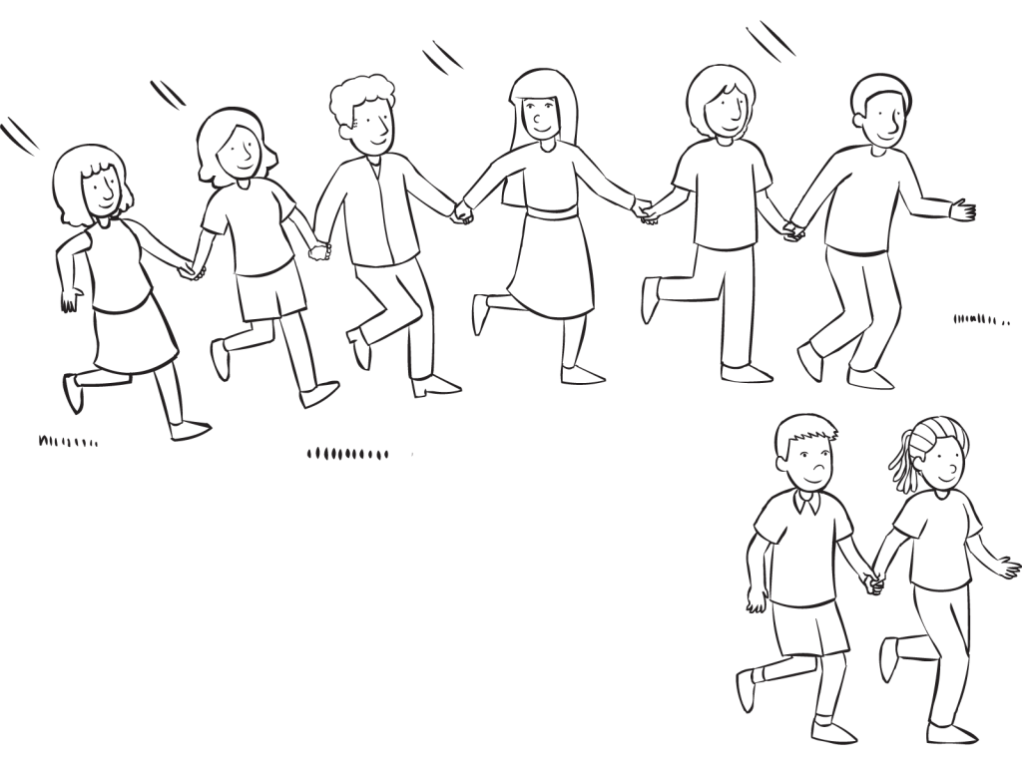

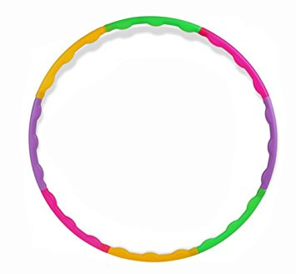
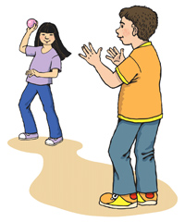
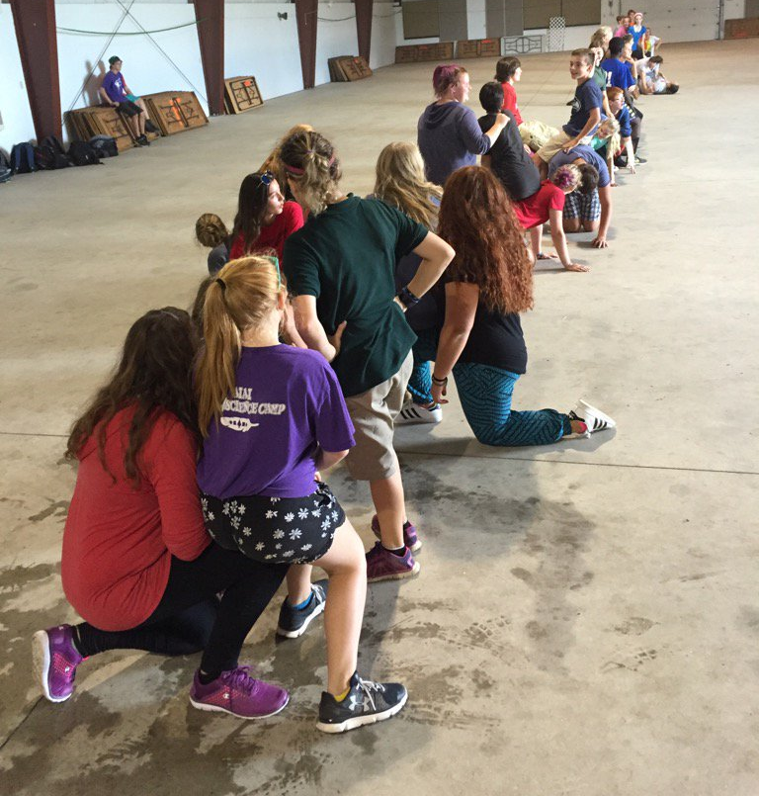

Chuck and Duck
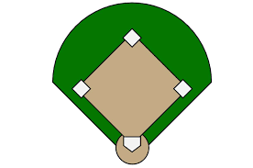
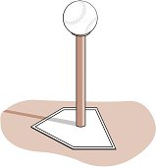
Musical Bases
Apple to Bucket
Race to the Base

Hold the Orange
Rock, Paper, Scissors Baseball
Zipper

Group Juggle
Steal the Bacon
Perfect Pass

Relay Race

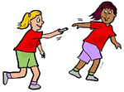
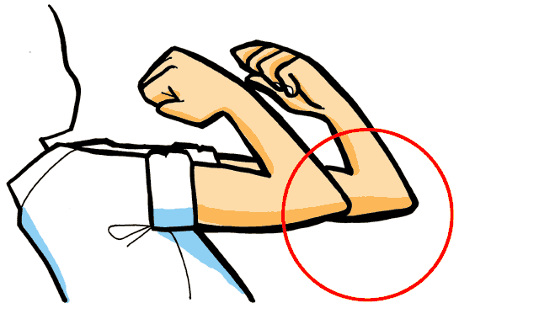

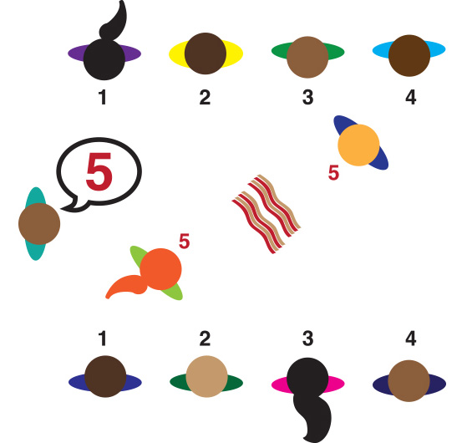
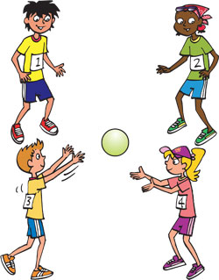
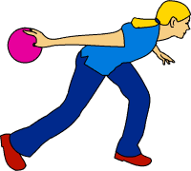

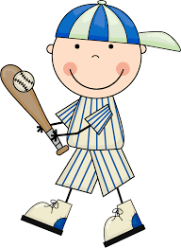
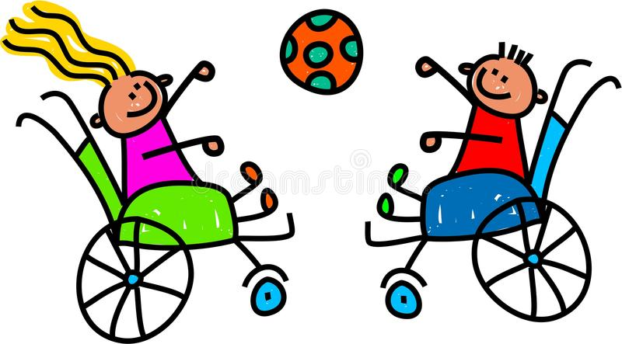

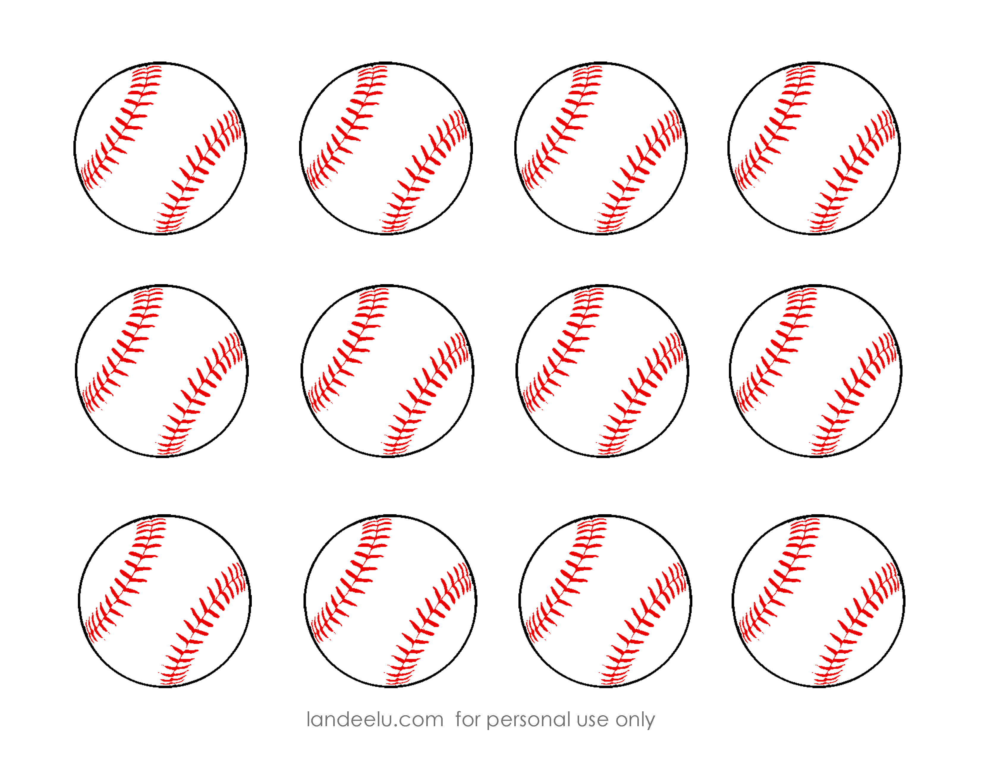

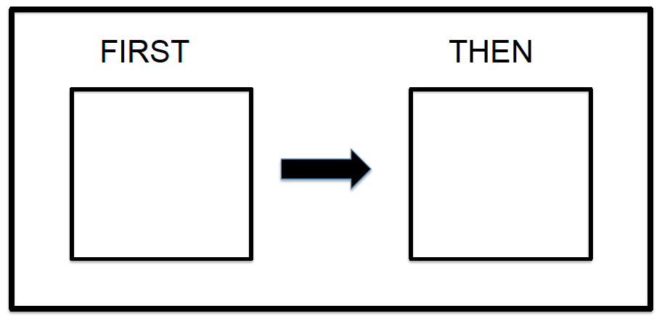

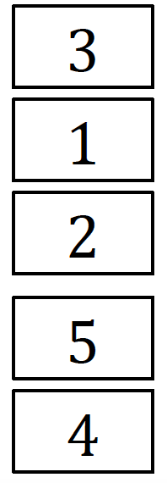
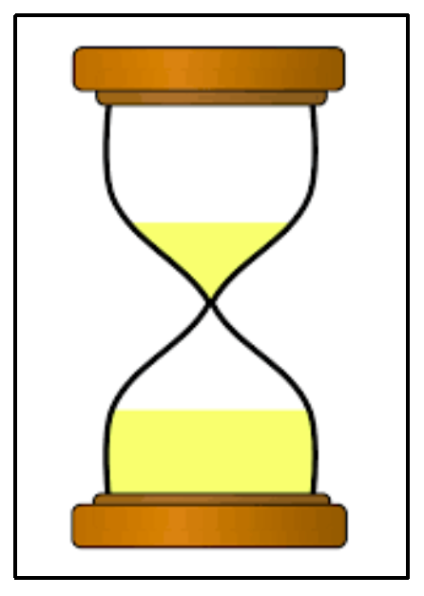

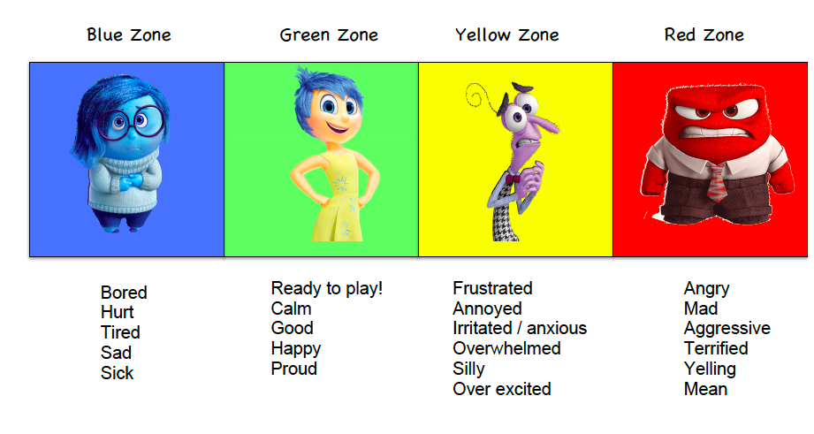

APPENDIX A: ADDITONAL TIPS AND STRATEGIES
- Avoid using the word “no”
  - This can be a trigger word for some individuals with exceptionalities. Instead of telling an athlete what not to do, be direct by explaining to them what you need them to do. (i.e. instead of… “No, you need to follow the Timer” say … “Lets follow the Timer to help us know when we are up to bat!”)

- Provide choice within limits
  - For example, “would you rather run or hit?” as it makes the individual feel as though they have a choice while the buddy is directing the options.

- Determine emotions
  - Use the Zones of Regulation tool to understand how athletes are feeling at the beginning of each session.

- Discover athlete’s preferred activities or interests
  - It is crucial that the Coach knows the athlete; specifically their interests and preferred activities as these can help motivate the athlete to stay engaged in Challenger Baseball events. This information can be relayed to the buddy.

- Have fun!
  - Most importantly, Challenger Baseball is for fun. If the child is feeling frustrated because of the visual aids, then try them again another time.

