SOBEYS HEALTHY ACTIVE ATHLETE CHALLENGES
Congratulations on being a Challenger Baseball athlete! It takes time, energy and commitment to be an athlete. If you are feeling motivated to take on some additional challenges to further develop your skills as a healthy active athlete, consider trying some of our amazing Sobeys Healthy Athlete Challenges below. Each time you complete a challenge, fill it out in the Challenge Tracker at the back of this booklet. When you’ve completed ten, send a copy of your Challenge Tracker to us at Jays Care and we will celebrate your efforts with a Healthy Athlete Reward Pack.
NOTE: You can complete the same challenge 10 times if you want. Good luck and have fun!
CHALLENGE # | SOBEYS HEALTHY CHALLENGE INSTRUCTIONS
GET MOVING CHALLENGES
1 | WALL BALL CHALLENGE: Make a big square target on a poster (or you can use chalk if it’s appropriate). Using a bouncy ball – see how many times you can bounce the ball off the target and catch it. Set your all-time best record. See if you can beat it each day for a week.
2 | BALLOON UP CHALLENGE: Blow up a balloon. See how long you can keep it bouncing in the air. Can you beat the Challenger Baseball world record (5 minutes)?
3 | DRILL CREATION CHALLENGE: Make up a new Challenger Baseball drill. Teach it to your friends or family. Write the instructions and send them to Jays Care (or ask someone to take a video of you teaching it).
4 | NATURE WALK CHALLENGE: Go for a nature walk and take 5 artistic photos.
5 | PLAYGROUND CHALLENGE: Visit a playground and try out each activity the playground has to offer as many times as you can in 20 minutes.
6 | BIG WALK CHALLENGE: Go for a 30 minute to 1 hour walk with a friend or family member.
7 | YOGA CHALLENGE: Do twenty minutes of yoga two nights in a row.
8 | HOP SCOTCH CHALLENGE: Using chalk, create the longest hopscotch course in the world (or at least one long enough to get excited about). Think about ways to make it more exciting than a regular hop scotch course (could people dance in certain spots?). Once completed, challenge friends and family (and yourself) to work through it at least a few times.
9 | DANCE CHALLENGE: Dance like no one’s watching for 3 songs in a row. If you’re feeling really motivated, encourage someone else in your family to dance with you.
LEARN MORE CHALLENGES
10 | HEALTH DETECTIVE CHALLENGE 1: Find out 5 important things about water and why humans need it. Create a poster that teaches other people those important facts.
11 | HEALTH DETECTIVE CHALLENGE 2: Time to research. Find out what happens to people’s bodies when they eat too much sugar. Make a poster that teaches why we should limit our sugar and gives people at least 3 ideas of low sugar foods they should try to eat more often.
12 | HEALTH DETECTIVE CHALLENGE 3: Find out why adults always tell us to eat more fruits and vegetables. Why are they so good for our bodies? Make a short commercial explaining the most important things you learn.
13 | SUGAR SUGAR CHALLENGE: Pick 6 different drinks that you can think of (for example, water, milk, orange juice, pop, energy drinks). For each drink, guess how much sugar is in each drink. Use the Sugar Sugar poster in this booklet to see if you were right. Next, invite 3 friends or family members to guess themselves. Celebrate their efforts and make sure they get the chance to learn the truth about sugar in drinks!
14 | PICTURE DRAWING CHALLENGE: Draw a picture of your 5 favourite healthy foods.
15 | COMMERCIAL CHALLENGE: Create a short commercial that challenges kids across the country to make healthy choices. Ask a parent or friend to videotape it.
16 | GRATITUDE CHALLENGE: Think about people in your life who encourage you to get active and be healthy. Write one of them a thank you note.
HEALTHY FOOD PREP CHALLENGES
17 | HEALTHY COOKIE CHALLENGE: Look up a healthy cookie recipe on line. Go and buy the ingredients. Then bake the healthy cookies for your family. Take a minute at dinner to explain why they are healthy.
18 | SMOOTHIE CHALLENGE: Using at least 3 different fruits or vegetables, make a healthy smoothie and drink it.
19 | YES TO WATER CHALLENGE: Say yes to H20! Challenge yourself to drink 8 glasses of water today!
20 | HEALTHY FRUIT PIZZA CHALLENGE: Try creating your own fruit pizza by using a whole great english muffin, yogurt and a variety of sliced fruit!
21 | FRIDGE DETECTIVE: Look through your fridge and cupboards. Pick out the ten items you think are the healthiest. Explain why you picked them to a family member. Make a healthy snack using at least two of the ingredients.
22 | COOKING CLASS CHALLENGE: Find a healthy cooking recipe on line. Prepare the meal/snack once following the instructions. The second time, ask someone to film you teaching how to make the meal/snack as though you are a cooking instructor.
GOAL SETTING CHALLENGES
23 | HEALTHY EATING GOAL SETTING CHALLENGE: Set three healthy eating goals for yourself. Track how well you do at meeting your goals over the course of a week.
24 | ACTIVE LIVING GOAL SETTING CHALLENGE: Set three active living goals for yourself that get you moving and active more than you usually are. Track how well you do at meeting your goals over the course of a week.
25 | BUCKET LIST CHALLENGE: Make a bucket list of at least 25 things you are most excited about doing in your lifetime. Share it with someone you care about.
26 | MAKE A GOAL-SETTING WHEEL OF FORTUNE: In each part of the wheel, write one healthy challenge you are willing to try (for example, do 20 push ups, or drink a full glass of water). Challenge yourself to spin a pen inside the wheel once a day and do whatever the tip of the pen lands on.  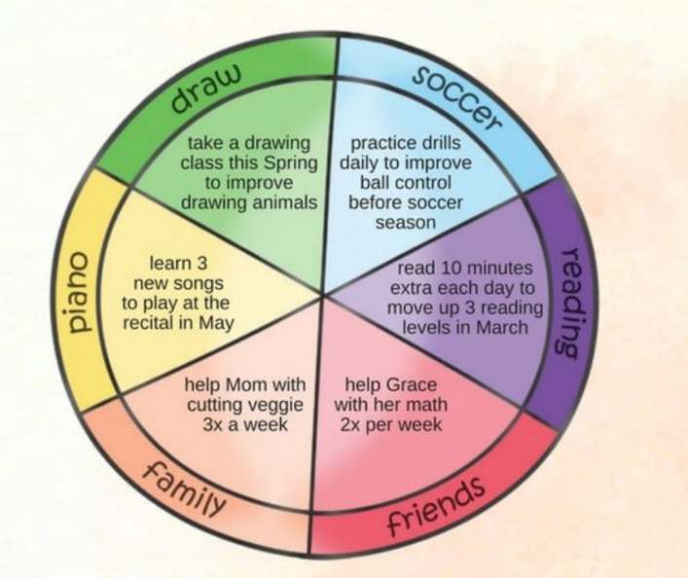
27 | STAY HYDRATED CHALLENGE: Set a goal to drink 8-10 glasses, or at least 2 Litres of water per day! Keep track of all the water you drink and see how well hydrated you are at the end of the day!
28 | FOOD GROUP CHALLENGE: After every meal, take note of all the Food Groups you had with your meal. Did you have Vegetables & Fruit, Meats & Protein, Grains, and Dairy? How many days in a row can you eat all 4 Food Groups?
29 | WEEKLY EXERCISE CHALLENGE: Set a goal to try 1 new exercise each day of the week and track how well you do at meeting your goal. What is your favourite new exercise?
30 | WEEKLY NUTRITION CHALLENGE: Set a goal to try 1 new food each day of the week and track how well you do at meeting your goal. What is your favourite new food?

CHALLENGE TRACKER
Track the number of challenges you have completed on the tracker below. For each line, include the name of the challenge and the date you completed it. Ask a family member, teacher or other supportive adult who saw you complete the challenge to sign their name confirming that you did the hard work. When you complete ten, send a copy of this tracker and any photos of the work you did to complete the challenges to our Challenger Baseball team at Meghan.saunderhook@bluejays.com. Once we receive it, we will send you a Healthy Athlete Reward Pack to celebrate your hard work!
Your full name:

Your mailing address:

City/Town:
Postal Code: |  |  |  | Province:
Challenge # | Challenge Name |  | Date you completed the challenge |  | Signature of caring adult who witnessed the challenge
