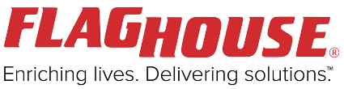
Challenger Baseball – School Equipment Kit
In partnership with FlagHouse Inc. we are able to provide specialized equipment allowing each Challenger Baseball Program taking place in schools to be creative and adapt their programming to meet the needs and unique goals of each athlete.

The items in an Adaptive Baseball Equipment Kit for schools include:
Item | QUANTITY |  | Item | QUANTITY
6 inch. Knobby Ball | Set of 5 | 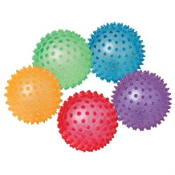 | 30” No Kink-Hoops  30 inch. Hoop Bag | 1 Dozen hoops, 1 bag | 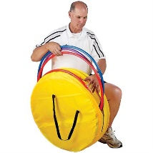
Jingle Bell Ball | Set of 6 | 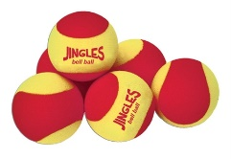 | Giant Equipment Bag | 1 | 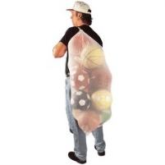
Soft Playground Ball | Set of 6 | 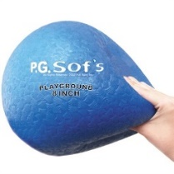 | Flyweight Ball | 3 hot – colour  3 - large | 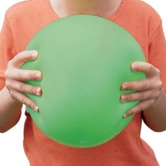
Multi-Buckets | 1 Dozen | 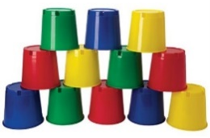 | Flaghouse Rock-Paper-Scissors Blocks | 2 | 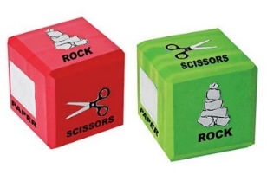
12” Six-Colour Cone Set | 1 Set | 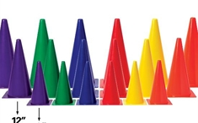 | SPOT MARKER SET | 1 | 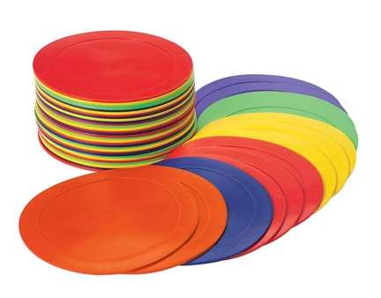
Bucket Fruits and Veggies | 1 Set | 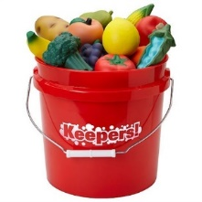 | Inflator + Inflating  Needles | 1 each | 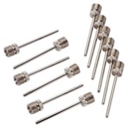
Soft Flex  Markers (50) | 1 Set | 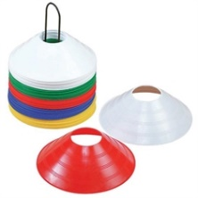 | Lightweight Plastic baseball Set | 1 Set | 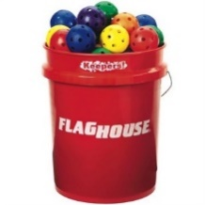
Sound Steps (6/set) | 1 Set | 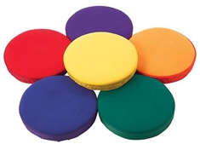 | health Food Spot Markers | 1 Set | 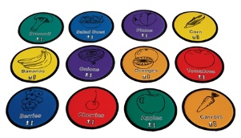

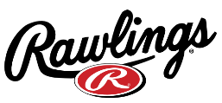
In partnership with Rawlings we are able to provide foam baseball equipment allowing each Challenger Baseball program taking place in schools to play indoors and/or outdoors.

The items in your Baseball Equipment Kit include:
Item | QUANTITY |  | Item | QUANTITY
5 piece throwdown base set | 2 | 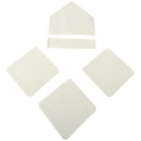 | wiffle balls  BIG BOY BALLS | 24  2 | 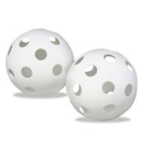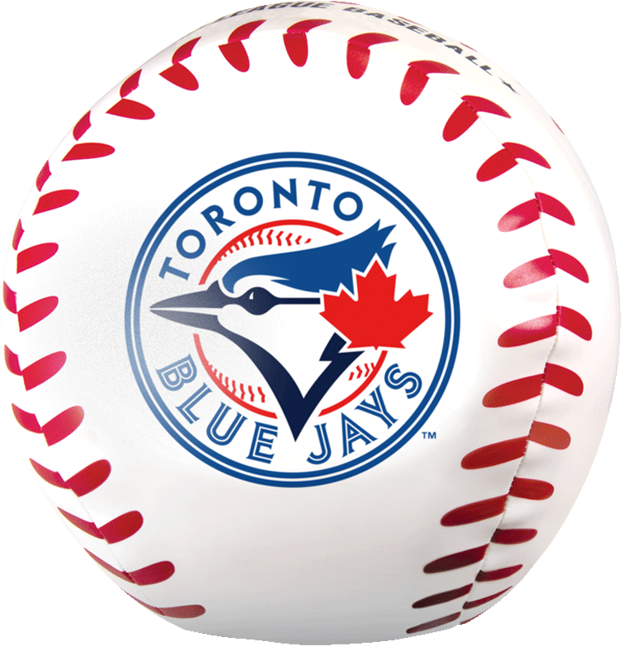
folding t’s | 4 | 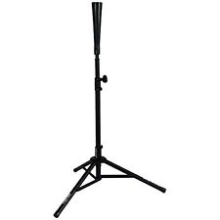 | blastball bats | 6
blastballs | 30 | 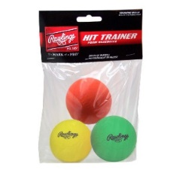 | equipment bag | 1 | 